memo

To: Model Users Group
From: PSRC Data Team
Re: LODES open employment dataset comparison to confidential QCEW data
Date: June 2018

PSRC strives to make its data and tools publicly available, including our forecast models and their inputs. However, PSRC’s to-date standard employment input for land use modeling draws heavily from disaggregate data from the State Employment Security Department’s (ESD) Quarterly Census of Employment & Wages (QCEW) product. This makes both the ESD product and the PSRC disaggregate forecasts of future employment distributions subject to legislated confidentiality restrictions and distributable only to those authorized by ESD. To achieve a freely distributable set of inputs for both land use and travel modeling, we have developed an alternative base year employment input without any such restrictions.
The primary basis of this new employment input is the block-level Longitudinal Employer-Household Dynamics (LEHD) Origin-Destination Employment Statistics (LODES) dataset. Although LODES is also primarily derived from QCEW data, there are some differences with PSRC’s covered employment dataset:
- LODES uses April as the representative month, where PSRC has historically used March.
- LODES is not available at precision below Census Block level; PSRC’s dataset is parcel-level.
- LEHD adjusts to compensate for records whose precise physical address cannot be located via automated processes. These adjustments are substantial, but PSRC has not found a description of the method used. PSRC uses manual correction when necessary to determine such locations in its own covered employment data.
- Noise is intentionally added to LODES to answer confidentiality needs.
- PSRC gathers additional data for public sector employers that do not report disaggregate locations to ESD. PSRC’s dataset is also carefully reviewed by staff experts from many of our jurisdictions to correct for errors or omissions.
Most of these differences (excepting #1) result in lower relative accuracy for the LODES dataset. PSRC is not able to compensate for items 3 & 4 but has applied our edits (#5) across to the LODES-based input. We have also used parcel and building characteristics to disaggregate it to parcels (#2), using an estimated, block-level version of the employment location model from our land use forecasting model (UrbanSim).
The purpose of this document is to compare the inputs as well as PSRC model results that use this LODES-based input with those that used our Covered Employment (PSRC-CE) data—specifically, the 2014 version used in the last Regional Transportation Plan. No other change to inputs or model configurations was made, as to isolate the impact to the employment data alone.
PSRC does not guarantee the consistency of results with its work using the LODES dataset but hopes that they will be useful to practitioners as a good starting point for employment data on any project.

2014 Modeling Base Year

2014 BASEYEAR data differences: PSRC-CE vs LODES
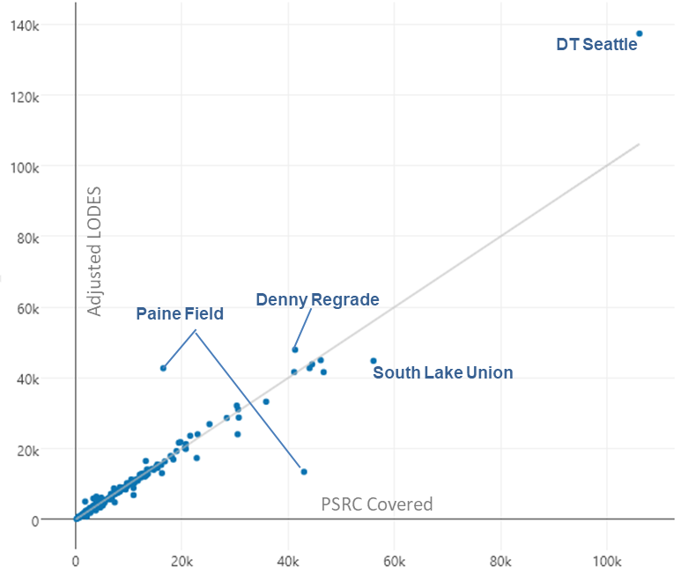
At the Forecast Analysis Zone (FAZ) level (shown below), the LODES input shows only a few major differences with the PSRC Covered Employment version—specifically, a trade-off between two blocks in Paine Field (i.e., jobs located on an adjoining block), and greater concentration in the LODES-based input for downtown Seattle (likely a result both of introduced noise, and of records without an actual physical presence in the state, reporting their employees to downtown Seattle as an expedient).

2014 soundcast differences: PSRC-CE Vs LoDES
The following table shows the differences between the 2014 SoundCast model run using the PSRC-CE employment dataset and adjusted LODES employment dataset. The results are similar for regional statistics.
The most notable difference is a slight increase in transit boardings (623,000 in the PSRC-CE run vs 653,000 in the LODES run) and transit mode share (3.2% in the ESD run, 3.4% in the LODES run). There is also a slight reduction in VMT from 80,834,000 in the ESD run to 80,444,130. The reduction in VMT results from people switching from auto trips to transit trips. The largest reason for the increase in transit trips relative to auto trips is from the greater concentration of jobs in downtown Seattle where there is the best transit service and highest density in the region.
2014 SoundCast Model Runs 2014 QCEW vs 2014 LODES

Model Run | 2014 ESD | 2014 LODES | Difference
Date Updated | 8/1/2017 | 3/22/2018
VMT | 80,834,412 | 80,444,132 | 390,280
VHT | 2,441,131 | 2,428,109 | 13,022
Delay | 464,584 | 458,938 | 5,646
Average Speed | 33.1 | 33.1 | 0
Mode Share
Bike | 1.70% | 1.70% | 0.0%
HOV2 | 22.40% | 22.20% | 0.2%
HOV3+ | 15.90% | 15.90% | 0.0%
SOV | 39.40% | 39.20% | 0.2%
School Bus | 2.30% | 2.30% | 0.0%
Transit | 3.20% | 3.40% | -0.2%
Walk | 15.20% | 15.40% | -0.2%
Walk+Bike | 16.90% | 17.10% | -0.2%
Total Transit Boardings | 622,845 | 653,157 | -30,312
Trips per Person | 3.86 | 3.87 | 0.0
Average Trip Length | 5.94 | 5.91 | 0.0
Average Daily Miles Driven per Person | 19.9 | 19.9 | 0.0
Hours of Congestion per Person per Year | 34 | 34 | 0.0
Annual Hours of Delay per Average Truck | 67.6 | 67.3 | 0.3
Medium trucks only | 58.5 | 58.4 | 0.1
Heavy trucks only | 102.2 | 101.9 | 0.3
% Population Walking or Biking for Transportation | 27.80% | 28.10% | 0.0
Annual Travel Costs per Household | $3,325 | $3,319 | $ 6
AM SOV Travel Times (minutes)
Seattle to Bellevue | 22 | 21 | 1
Seattle to Redmond | 24 | 23 | 1
Seattle to Everett | 44 | 43 | 1
Seattle to Tacoma | 46 | 46 | 0
Bellevue to Seattle | 26 | 27 | -1
Bellevue to Tukwila | 31 | 30 | 1
Bellevue to Lynnwood | 28 | 28 | 0
Lynnwood to Bellevue | 43 | 43 | 0
Everett to Seattle | 64 | 65 | -1
Tacoma to Seattle | 66 | 66 | 0
Bremerton to Silverdale | 17 | 17 | 0
Silverdale to Bremerton | 18 | 18 | 0
Redmond to Seattle | 30 | 30 | 0
Auburn to Renton | 28 | 28 | 0
Renton to Auburn | 21 | 21 | 0
Tukwila to Bellevue | 35 | 35 | 0
PM SOV Travel Times (minutes
Seattle to Bellevue | 26 | 26 | 0
Seattle to Redmond | 28 | 29 | -1
Seattle to Everett | 64 | 65 | -1
Seattle to Tacoma | 66 | 66 | 0
Bellevue to Seattle | 24 | 24 | 0
Bellevue to Tukwila | 37 | 37 | 0
Bellevue to Lynnwood | 44 | 44 | 0
Lynnwood to Bellevue | 29 | 29 | 0
Everett to Seattle | 48 | 47 | 1
Tacoma to Seattle | 48 | 47 | 1
Bremerton to Silverdale | 17 | 17 | 0
Silverdale to Bremerton | 17 | 17 | 0
Redmond to Seattle | 26 | 25 | 1
Auburn to Renton | 21 | 21 | 0
Renton to Auburn | 29 | 29 | 0
Tukwila to Bellevue | 30 | 30 | 0

2040 Constrained Plan with Land Use Vision
The 2040 Constrained Plan is the name for the regionally preferred alternative transportation network. The land use assumptions come from PSRC’s Land Use Vision version 2 (LUV 2) forecast product, in which Regional Growth Strategy policies are used to determine 2040 levels of household and employment growth at a city and town level. PSRC’s UrbanSim model is used to generate sub-city detail, starting from either a LODES or PSRC-CE employment baseyear and simulating annual growth until 2040. However, because employment levels of both versions are determined at city/ town level, differences between the two are modest, with no difference at scales of city/town or larger.

2040 LAND USE Vision differences: PSRC-CE vs lodes
At the Forecast Analysis Zone (FAZ) level (shown below), most 2040 differences between a model result using the adjusted LODES baseyear differ only on the scale of random error with results utilizing the PSRC-CE baseyear. Little difference in downtown Seattle remains, though elsewhere in Seattle some baseyear differences are still recognizable (e.g. South Lake Union).
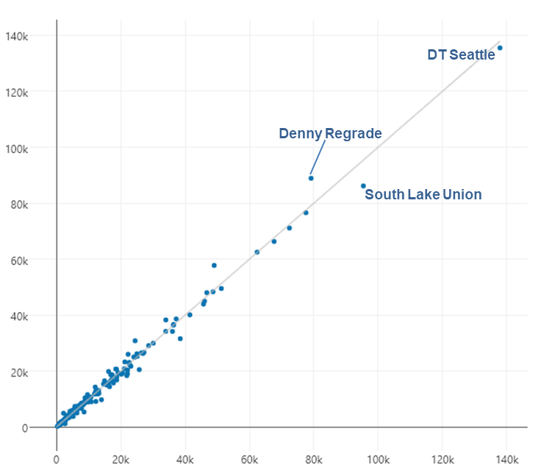

2040 constrained plan soundcast differences: ESD VS Lodes
Sub-jurisdictional differences between the LODES-based or PSRC-CE based 2040 modeling result do not notably impact any of the regional statistics from a 2040 SoundCast run; these results are functionally equivalent.
2040 SoundCast Model Runs 2040 ESD vs 2040 LODES
Model Run | 2040 Constrained Plan ESD | 2040 Constrained Plan LODES | Difference
Date Updated | 8/23/2017 | 4/19/2018
VMT | 97,418,056 | 97415837 | 2,219
VHT | 3,100,689 | 3100928 | -239
Delay | 689,426 | 692006 | -2,580
Average Speed | 31 | 31 | 0
Mode Share
Bike | 2.10% | 2.10% | 0.0%
HOV2 | 21.30% | 21.40% | -0.1%
HOV3+ | 14.40% | 14.50% | -0.1%
SOV | 37.40% | 37.20% | 0.2%
School Bus | 2.10% | 2.10% | 0.0%
Transit | 4.60% | 4.50% | 0.1%
Walk | 18.20% | 18.20% | 0.0%
Walk+Bike | 20.30% | 20.30% | 0.0%
Total Transit Boardings | 1,281,574 | 1,260,211 | 21,363
Trips per Person | 3.9 | 3.88 | 0.0
Average Trip Length | 5.38 | 5.43 | 0.0
Average Daily Miles Driven per Person | 18.4 | 18.4 | 0.0
Hours of Congestion per Person per Year | 38.9 | 39 | -0.1
Annual Hours of Delay per Average Truck | 91.4 | 92.1 | -0.7
Medium trucks only | 77 | 77 | 0.0
Heavy trucks only | 154.6 | 156.8 | -2.2
% Population Walking or Biking for Transportation | 32.30% | 32.10% | 0.0
Annual Travel Costs per Household | $4,195 | $4,218 | $ (23)
AM SOV Travel Times (minutes)
Seattle to Bellevue | 22 | 22 | 0
Seattle to Redmond | 24 | 24 | 0
Seattle to Everett | 49 | 49 | 0
Seattle to Tacoma | 52 | 52 | 0
Bellevue to Seattle | 26 | 26 | 0
Bellevue to Tukwila | 29 | 29 | 0
Bellevue to Lynnwood | 28 | 28 | 0
Lynnwood to Bellevue | 42 | 41 | 1
Everett to Seattle | 69 | 69 | 0
Tacoma to Seattle | 77 | 79 | -2
Bremerton to Silverdale | 17 | 17 | 0
Silverdale to Bremerton | 20 | 20 | 0
Redmond to Seattle | 30 | 29 | 1
Auburn to Renton | 32 | 33 | -1
Renton to Auburn | 23 | 23 | 0
Tukwila to Bellevue | 36 | 36 | 0
PM SOV Travel Times (minutes
Seattle to Bellevue | 25 | 25 | 0
Seattle to Redmond | 28 | 28 | 0
Seattle to Everett | 70 | 70 | 0
Seattle to Tacoma | 76 | 78 | -2
Bellevue to Seattle | 24 | 24 | 0
Bellevue to Tukwila | 36 | 36 | 0
Bellevue to Lynnwood | 41 | 42 | -1
Lynnwood to Bellevue | 30 | 29 | 1
Everett to Seattle | 54 | 54 | 0
Tacoma to Seattle | 55 | 54 | 1
Bremerton to Silverdale | 19 | 19 | 0
Silverdale to Bremerton | 18 | 18 | 0
Redmond to Seattle | 27 | 27 | 0
Auburn to Renton | 24 | 24 | 0
Renton to Auburn | 33 | 34 | -1
Tukwila to Bellevue | 33 | 33 | 0

Looking forward
The LODES-based 2014 employment dataset summarized in this document is an initial version but will not be the last. PSRC intends to transition our own modeling away from the PSRC-CE-derived (confidential) baseyear dataset to a subsequent version of the adjusted LODES baseyear dataset. We welcome your feedback regarding this dataset and will take your comments into consideration as we improve on our methods of processing it (including adjustments).
Please feel free to contact us with any questions.

